Smoke testing of the sewer system is scheduled to begin Monday May 22, 2017 and will last approximately 5 days. In the event of inclement weather, the smoke testing will continue into the following week.

Smoke testing will be performed adjacent to South Davis Avenue in an area approximately bounded by the river, Industrial Park Drive, and Conway Drive, as well as the Teaberry Hills area and areas around Sycamore Street adjacent to Davis & Elkins College.

Each day the City of Elkins will notify the fire and police departments as to where sewer system smoke testing will be conducted. If you have any doubt as to the source of the smoke in your home, immediately call 911.

If you have any questions prior to or during smoke testing please call the City of Elkins Operations Division, at
304-635-7021.

Q. What is the purpose of smoke testing?
A. To find possible leaks in the sewer system allowing clear water to enter the sanitary sewer system (waste water system). Leaky sewer pipes have the potential to create downstream overflows and basement backups.
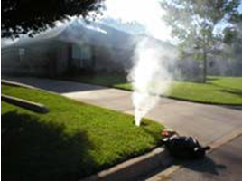
Figure 1. Leaky Pipe Found by Smoke Testing
Q. Is the smoke used for testing the sewer system harmful to humans and animals?
A. No. It may make you cough, but it is not harmful to you, your pets or your plants, and it will not harm clothing, drapes, or furniture. If there are individuals in your home who have respiratory problems and are immobile, please notify the Operations Division at 304-635-7021.

Q. What should I do to prevent smoke from entering
Figure 3. Properly Vented Home.
the house?
A. Make sure all your drain pipes have had water run through them recently. Simply flush toilets and pour one gallon of water into all drains, including floor drains in the basement floor. This will ensure that the traps in the pipes contain water, which will help prevent smoke from flowing into your home (see Figure 2). If the traps are full of water and the house properly plumbed, the test smoke should vent out through the sewer vent stack on your roof (See Figure 3).
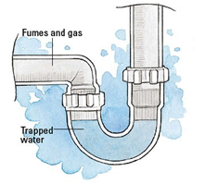

Figure 2. Typical plumbing trap that prevents sewer gas (and smoke from entering homes).

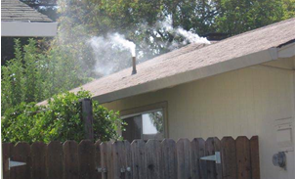

Q. If smoke gets into my home, how long will it take for the smoke to dissipate?
A. It depends upon how much smoke enters the building. Providing ample ventilation allows the smoke to dissipate more quickly.

Q. I’m not going to be home during smoke testing and have pets in the house, what should I do?
A. Although the smoke is not harmful to pets, leave several windows partially open for their comfort. If you have proper plumbing connections and all of the water traps in your pipes have water in them, there should not be any smoke inside your home.

Q. Can the smoke testing activate the smoke alarms?
A. Yes, smoke alarms may be activated during smoke testing. Make sure to open windows and/or doors for ventilation. If you have any doubts about the origin of the smoke, please call 911.

Q. What happens to the information inspection crews find?
A. This information will be documented and used by the City of Elkins to identify needed repairs that will reduce the inflow and infiltration of clear water into the combined sewer system.

